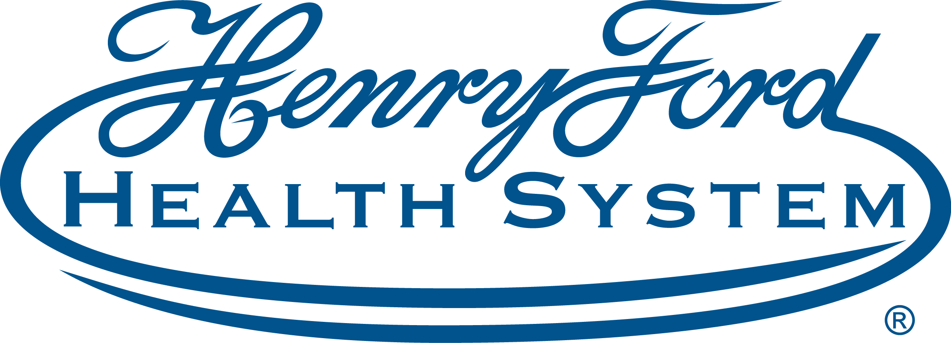
Updates in Ophthalmology - Alumni Education Day | 5/22/2021 8:00:00 AM Online
This will be a virtual event.
The Guyton lecture subject rotates between the major subspecialties in ophthalmology (retina, cornea, oculoplastic, neuro-ophthalmology, pediatrics, uveitis, etc.) The 2021 Jack S. Guyton Memorial Lecture will be presented by James Tsai, MD.
The Sugar lecture is dedicated each year to glaucomatous disease and a leader in his field is chosen each year to participate. The 2021 H. Saul Sugar Lecture in Glaucoma will be presented by Ike Ahmed, MD.
The Philip C. Hessburg lecture is a lectureship intended to highlight the contributions of Michigan ophthalmologists to the vision care of patients worldwide. The 2021 Philip C. Hessburg lecture will be presented by Frank Nesi, MD.
Many eye care providers find it difficult to keep up with the latest developments in ophthalmology research. As part of the annual Alumni meeting program, senior staff ophthalmologists, researchers, fellow, resident staff and alumni present the findings of investigations and research projects conducted during the past year. A portion of our program is intended to address this gap in knowledge by providing presentations on some of the most recent developments in ophthalmology research. During this portion of the program individuals will be selected to provide recent medical or surgical developments in the various sub-specialty areas of ophthalmology. Consequently, those in attendee will have the opportunity to learn about some of the most innovative accomplishments in the field.
At the conclusion of this CME activity, attendees will have gained an understanding of the latest trends in disease detection, clinical management and medical therapy. Attendees will also obtain knowledge in the latest research being conducted by the Henry Ford health System Department of Ophthalmology as well as by HFHS alumni throughout the United States.

Program Goal
1 To provide through presentations from thought leaders in Ophthalmology information that analyzes and summarizes new ideas procedures and technology so that clinicians can apply this knowledge to patient care. To more rapidly disseminate the knowledge acquired from ophthalmic research so that clinicians have an increased awareness of this information.
Target Audience Ophthalmology
Faculty
Name of individual | Individual's role in activity | Name of commercial interest/Nature of relationship
Roseanne Horne | Activity Coordinator | Nothing to disclose - 11/04/2020
Paul Edwards, MD | Co-Director | Nothing to disclose - 10/12/2020
David J Goldman, M.D. | Course Director | Nothing to disclose - 05/21/2021
Ike Amed, MD | Faculty | Consulting Fee-Johnson and Johnson|Consulting Fee-W. L. Gore and Associates, Inc. - 02/04/2021
Abdualrahman Hamad, MD | Faculty | Nothing to disclose - 05/11/2021
Man L Jin, MD-Resident | Faculty | Nothing to disclose - 05/06/2021
Daniel Kaitis, MD-Resident | Faculty | Nothing to disclose - 05/09/2021
Stephen Kaufman, MD, PhD | Faculty | Nothing to disclose - 02/10/2021
David Lu, MD-Resident | Faculty | Nothing to disclose - 05/18/2021
Shravani Mikkilineni, MD-Resident | Faculty | Nothing to disclose - 05/06/2021
Frank Nesi, MD | Faculty | Nothing to disclose - 02/16/2021
Sina Rezaei, MD-Resident | Faculty | Nothing to disclose - 05/13/2021
James C Tsai, MD, MBA | Faculty | Consulting Fee-Eyenovia|Consulting Fee-ReNetX Bio - 02/08/2021
Candice Yousif, MD | Faculty | Nothing to disclose - 05/17/2021
Fuxiang Zhang, MD | Faculty | Nothing to disclose - 05/12/2021

ACCREDITATION STATEMENT: Henry Ford Health System is accredited by the Accreditation Council for Continuing Medical Education (ACCME) to provide continuing medical education for physicians.
DESIGNATION STATEMENT: Henry Ford Health System designates this educational activity for a maximum of 6.50 AMA PRA Category 1 Credit(s)™. Physicians should only claim credit commensurate with the extent of their participation in the activity.
FACULTY/PLANNING COMMITTEE DISCLOSURE STATEMENT: In Compliance with the ACCME Standards for Commercial Support, all individuals in a position to control/influence the content of this activity are required to disclose relevant financial interests of their own or spouse or partners with any ACCME defined commercial interests for the past 24 months and/or any non-FDA approved use of a drug or a device that is included in the presentation. All relevant financial relationships have been mitigated.
ACCESSIBILITY STATEMENT: Henry Ford Health System Office of Continuing Medical Education is committed to ensuring that its programs, services, goods and facilities are accessible to individuals with disabilities as specified under Section 504 of the Rehabilitation Act of 1973 and the Americans with Disabilities Amendments Act of 2008. If you have needs that require special accommodations, including dietary concerns, please contact the CME Conference Coordinator.

