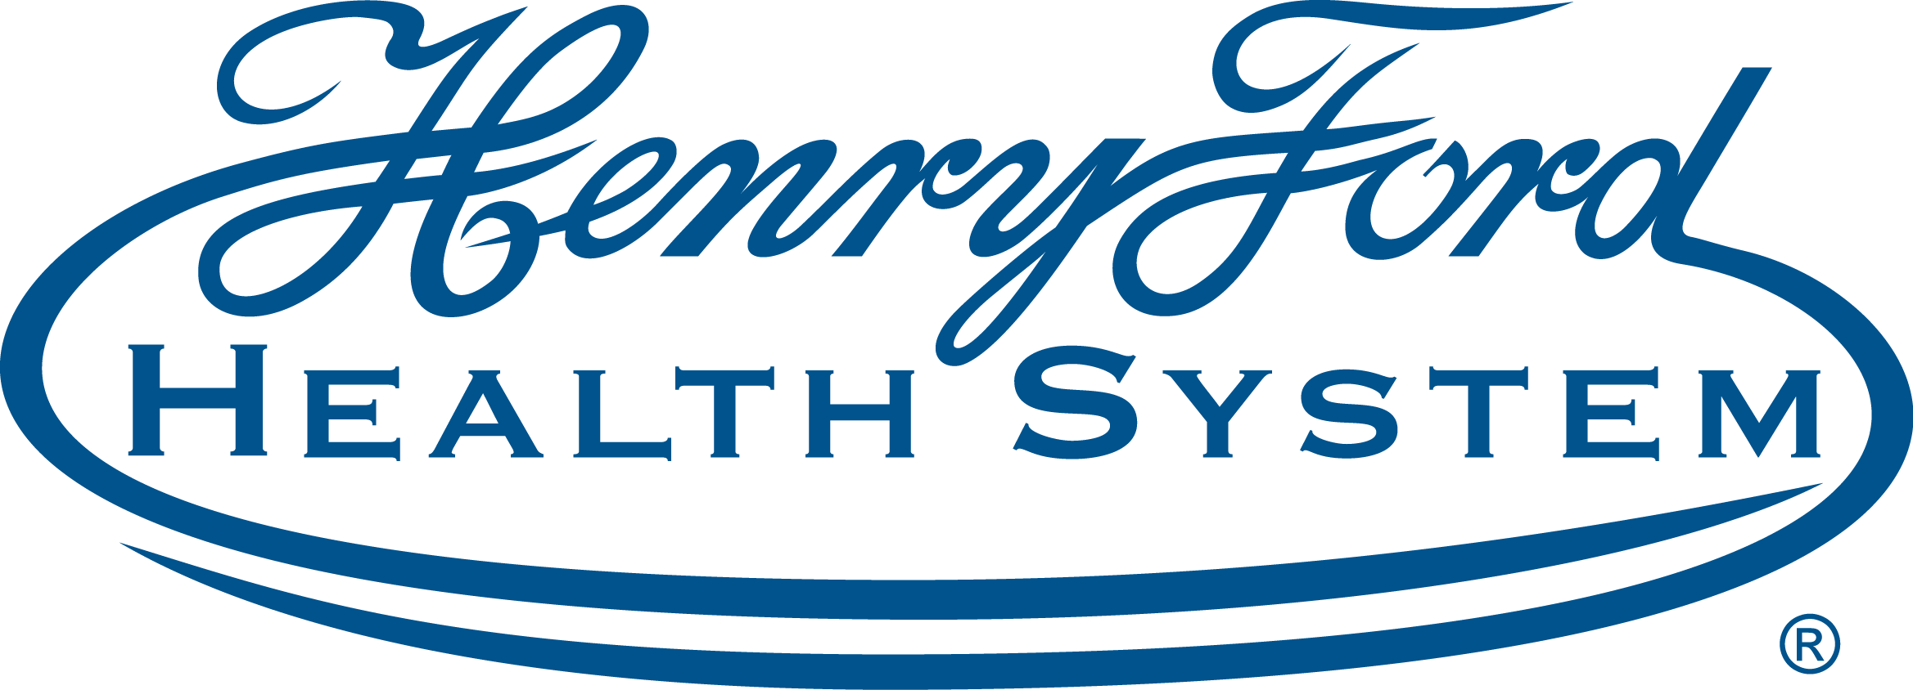
PALS (Pediatric Advanced Life Support) - Retrainer (5/13/21) | 5/13/2021 7:45:00 AM Henry Ford Hospital - Simulation Center
This classroom, Instructor-led course uses a series of videos and simulated pediatric emergencies to reinforce the important concepts of a systematic approach to pediatric assessment, basic life support, PALS treatment algorithms, effective resuscitation, and team dynamics. (Credit: AHA) This class is for those that are renewing their PALS certification ONLY.

Program Goal
1 To standardize assessment and treatment approaches of pediatric patients to improve the recognition, treatment, and outcomes of seriously ill and injured children.
2 To prepare and practice various serious illness presentations of children including cardiac arrest.
3 To practice airway and vascular access skills as well as cardiopulmonary resuscitation hands.
Target Audience Anesthesiology, Emergency Medicine / Internal Medicine, Emergency Medicine, Family Medicine, Internal Medicine, Surgery, Emergency Medicine/Internal Medicine/Critical Care, Allergy And Immunology, Critical Care Medicine, Pediatrics
Faculty
Name of individual | Individual's role in activity | Name of commercial interest/Nature of relationship
Christina Miller, BS | CME Specialist | Nothing to disclose - 06/10/2020

ACCREDITATION STATEMENT: Henry Ford Health System is accredited by the Accreditation Council for Continuing Medical Education (ACCME) to provide continuing medical education for physicians.
DESIGNATION STATEMENT: Henry Ford Health System designates this educational activity for a maximum of 8.50 AMA PRA Category 1 Credit(s)™. Physicians should only claim credit commensurate with the extent of their participation in the activity.
FACULTY/PLANNING COMMITTEE DISCLOSURE STATEMENT: In Compliance with the ACCME Standards for Commercial Support, all individuals in a position to control/influence the content of this activity are required to disclose relevant financial interests of their own or spouse or partners with any ACCME defined commercial interests for the past 24 months and/or any non-FDA approved use of a drug or a device that is included in the presentation. All relevant financial relationships have been mitigated.
Accessibility Statement: Henry Ford Health System Office of Continuing Medical Education is committed to ensuring that its programs, services, goods and facilities are accessible to individuals with disabilities as specified under Section 504 of the Rehabilitation Act of 1973 and the Americans with Disabilities Amendments Act of 2008. If you have needs that require special accommodations, including dietary concerns, please contact the CME Conference Coordinator.

