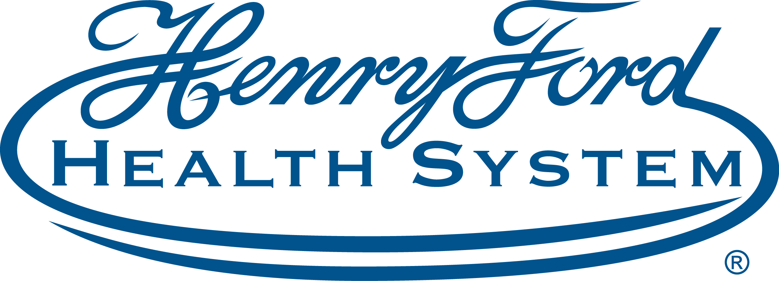
Detroit Stroke Conference (Virtual) - 11/3/21 | 11/3/2021 7:30:00 AM Online
The Henry Ford Neuroscience Institute is pleased to host the 2021 Detroit Stroke Digital Conference from 8 a.m. to 4:30 p.m., Wednesday, November 3rd. Leaders in stroke and neurovascular medicine are making breakthroughs all over the world. But we’re gathering some of the finest minds in medicine to discuss the latest research and data surrounding the diagnosis and treatment of stroke, presented online in a live, virtual format you won’t want to miss. Experience their expertise in a format that’s as fast as it is engaging. Presented in a TED-style talk, you’ll hear high-level insights from different thought leaders. Learn more about the latest treatments, techniques and trends in stroke care and see how they can strengthen your program.

Program Goal
1 Providers will be able to improve speed, quality and outcomes of stroke treatment
2 Providers will be able to apply up-to-date information in the care of patients with vascular anomalies and refer them to centers with the capability to treat such cases
3 RNs will be able to apply updated stroke guidelines and improve patient outcomes
4 EMS providers and stroke team members will have a better understanding of recommended stroke destinations and why
Target Audience Neurology
Faculty
Name of individual | Individual's role in activity | Name of commercial interest/Nature of relationship
Megan Brady, MSW | Activity Administrator, Faculty | Nothing to disclose - 09/15/2021
Hannah Beels, BHSA | CME Reviewer | Nothing to disclose - 10/05/2021
Crystal M Gyiraszin, MS | CME Reviewer | Nothing to disclose - 02/25/2021
Christina Miller, BS | CME Specialist | Nothing to disclose - 06/11/2021
Alex B Chebl, MD, FSVIN | Course Director, Faculty | Consulting Fee-Medtronic, Inc.|Consulting Fee-Contego - 03/10/2021
Rose Ballard, NP | Faculty | Nothing to disclose - 07/14/2021
Michael Chopp, PhD | Faculty | Nothing to disclose - 09/17/2021
Lisa Cohen, MSN | Faculty | Nothing to disclose - 07/01/2021
Rishi Gupta, MD, MBA | Faculty | Contracted Research-Stryker Neurovascular|Contracted Research-Rapid Medical|Contracted Research-Zoll|Contracted Research-Vesalio - 07/08/2021
Hebah Hefzy, MD | Faculty | Nothing to disclose - 07/01/2021
Tudor Jovin, MD | Faculty | Nothing to disclose - 07/20/2021
Owais Khadem Alsrouji, MD | Faculty | Nothing to disclose - 07/01/2021
Max Kole, MD | Faculty | Nothing to disclose - 07/07/2021
Christopher Lewandowski, MD, Senior Staff Physicain | Faculty | Nothing to disclose - 07/01/2021
Horia Marin, MD | Faculty | Nothing to disclose - 07/01/2021
Daniel Miller, MD | Faculty | Nothing to disclose - 07/01/2021
Lauren Ottenhoff, DO | Faculty | Nothing to disclose - 07/06/2021
Ahmad Riad Ramadan, MD | Faculty | Nothing to disclose - 06/23/2021
Mohammed Rehman, DO | Faculty | Speakers Bureau-Portola Pharmaceuticals, Inc. - 08/10/2021

ACCREDITATION STATEMENT: Henry Ford Health System is accredited by the Accreditation Council for Continuing Medical Education (ACCME) to provide continuing medical education for physicians.
DESIGNATION STATEMENT: Henry Ford Health System designates this educational activity for a maximum of 7.00 AMA PRA Category 1 Credit(s)™. Physicians should only claim credit commensurate with the extent of their participation in the activity.
FACULTY/PLANNING COMMITTEE DISCLOSURE STATEMENT: In Compliance with the ACCME Standards for Commercial Support, all individuals in a position to control/influence the content of this activity are required to disclose relevant financial interests of their own or spouse or partners with any ACCME defined commercial interests for the past 24 months and/or any non-FDA approved use of a drug or a device that is included in the presentation. All relevant financial relationships have been mitigated.
ACCESSIBILITY STATEMENT: Henry Ford Health System Office of Continuing Medical Education is committed to ensuring that its programs, services, goods and facilities are accessible to individuals with disabilities as specified under Section 504 of the Rehabilitation Act of 1973 and the Americans with Disabilities Amendments Act of 2008. If you have needs that require special accommodations, including dietary concerns, please contact the CME Conference Coordinator.

