How to Access Enduring Material Course – For Attendees
Please click on this link to access the HFHS CloudCME website: https://hfhs.cloud-cme.com/default.aspx
- Sign into your account by clicking the Sign In button:
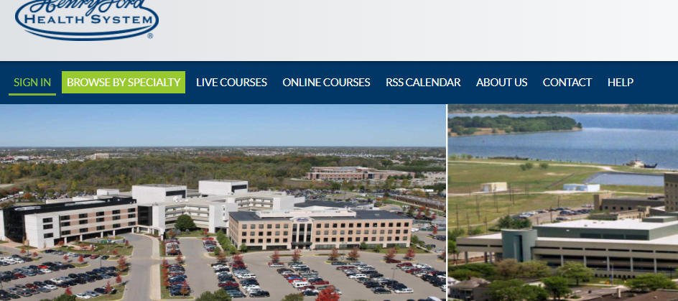

- Once logged in, click Online Courses:

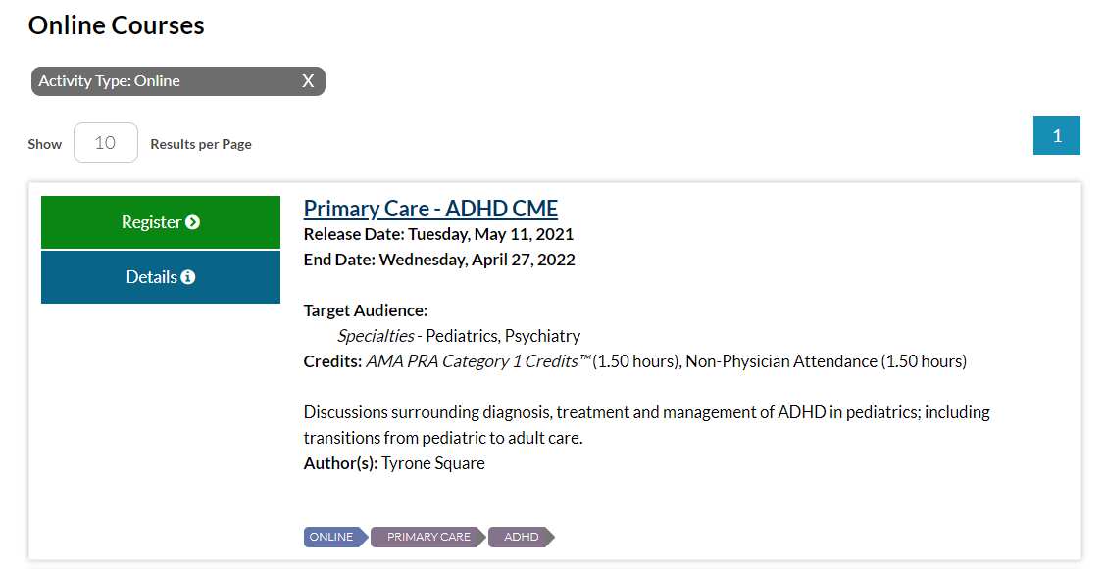
- Find your course, then click Register:

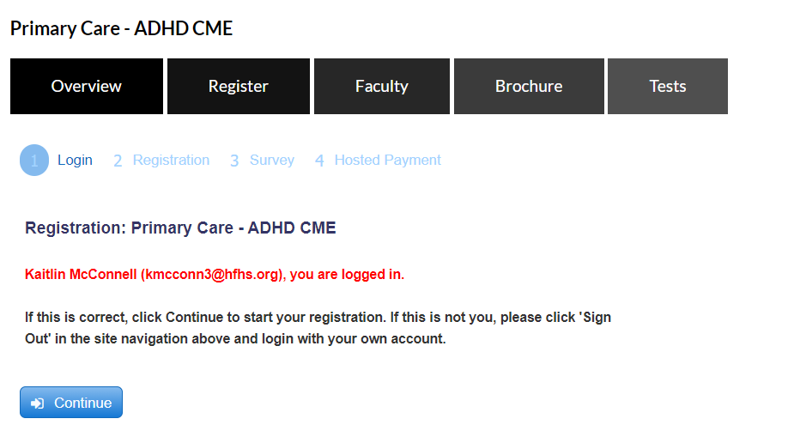
- Click on Continue button:

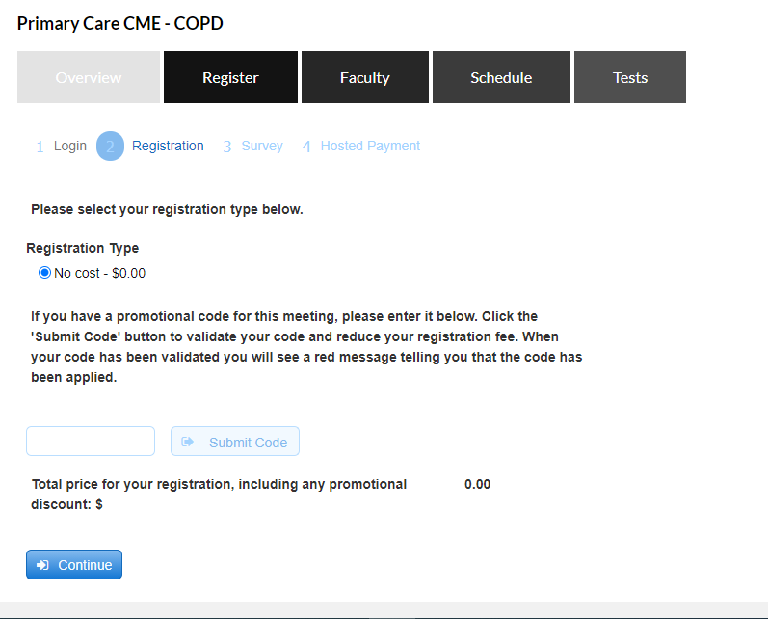
- Click on Continue again (leave promotional code blank):

- Check a box in the red shaded area and click Continue again:
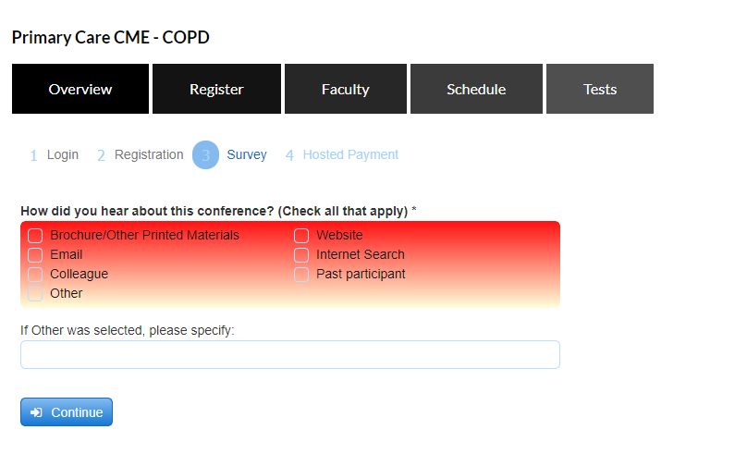

- Click Finish:
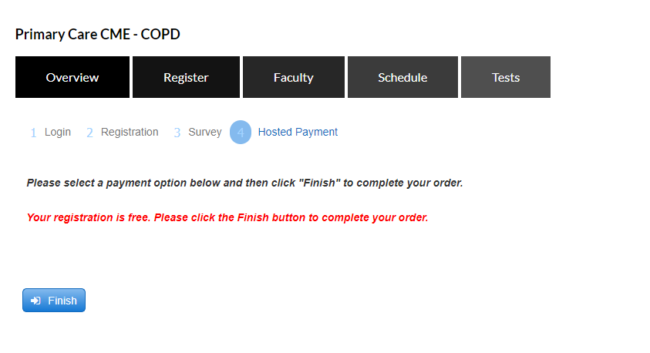

- Registration receipt can be sent to email, printed, or just close out:
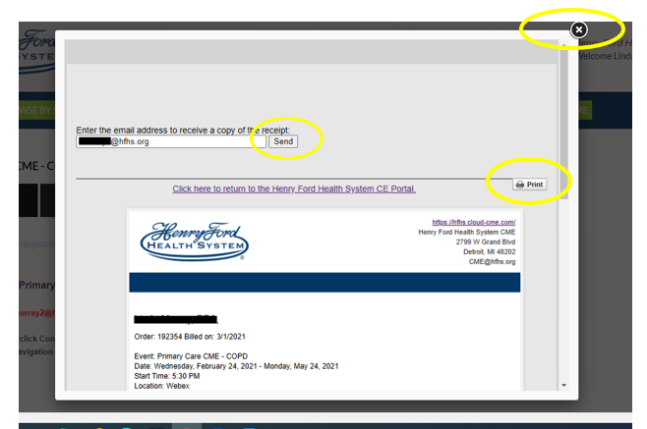

- Click on Tests button to launch the course:
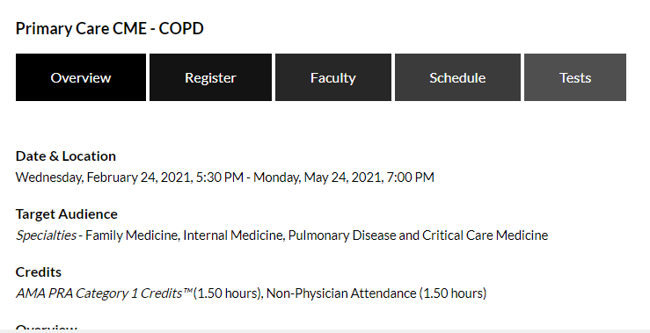

- If there is a Pre-Test required, you will click the Pre-Test button (you will not be able to launch video until pre-test is complete). If there is no pre-test, skip to step 10:
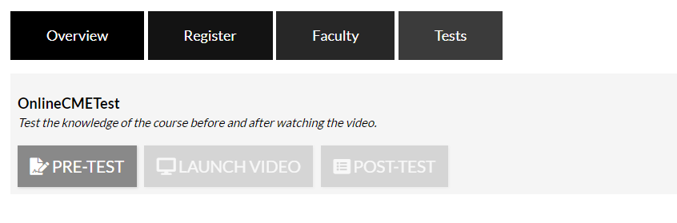

- Click on Launch Video to view the Course:
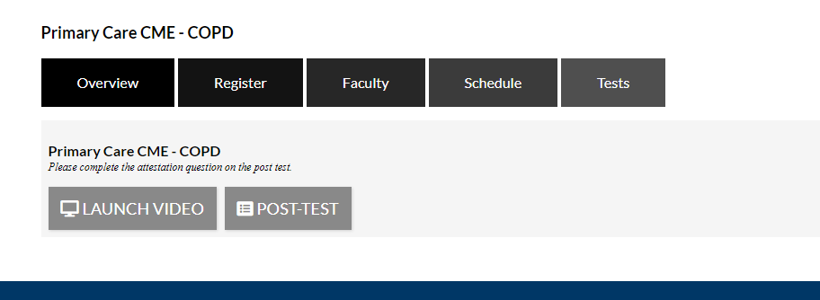

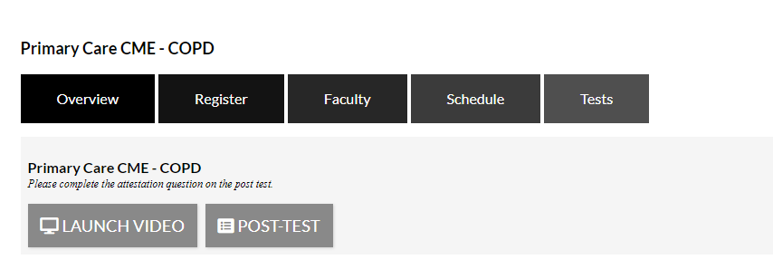
- After viewing complete video, click on Post-Test:

- Attest to watching the complete video and click on the Check Answer button & then click the Show Results button to access the evaluation:

- Click on Complete Evaluation:
